Scratch Sample

* Setup environment:

# sh ./setup.sh

* Uninstall environment:

# sh ./uninstall.sh

1. Sample 1 – gpio input functions
2. Double click the following icon

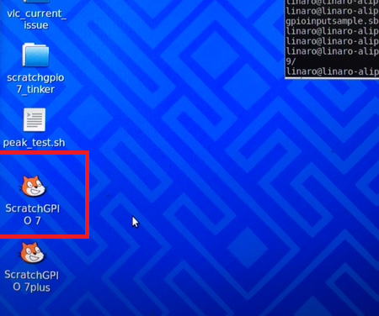

1. Open the sample code

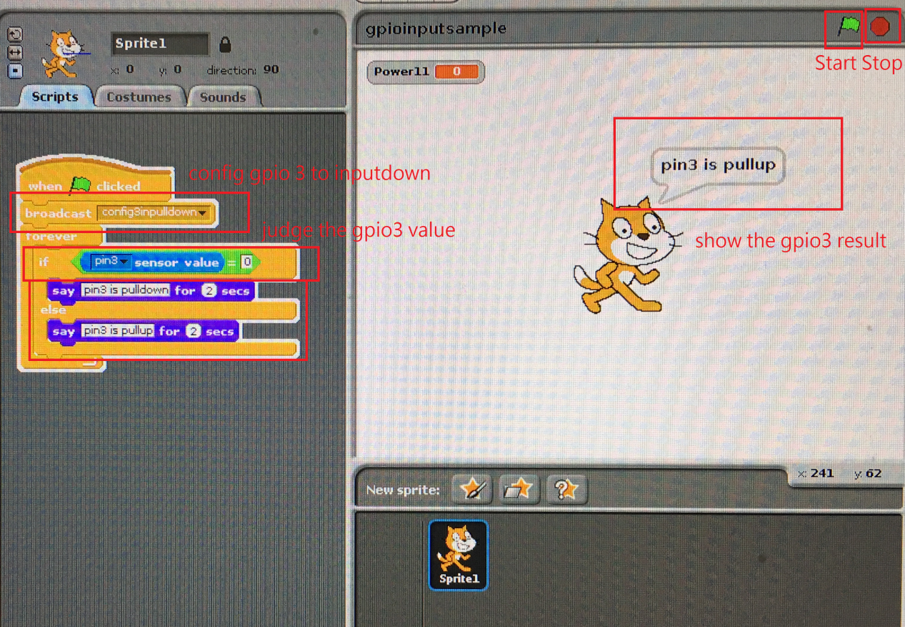

1. Pull the gpio3 down

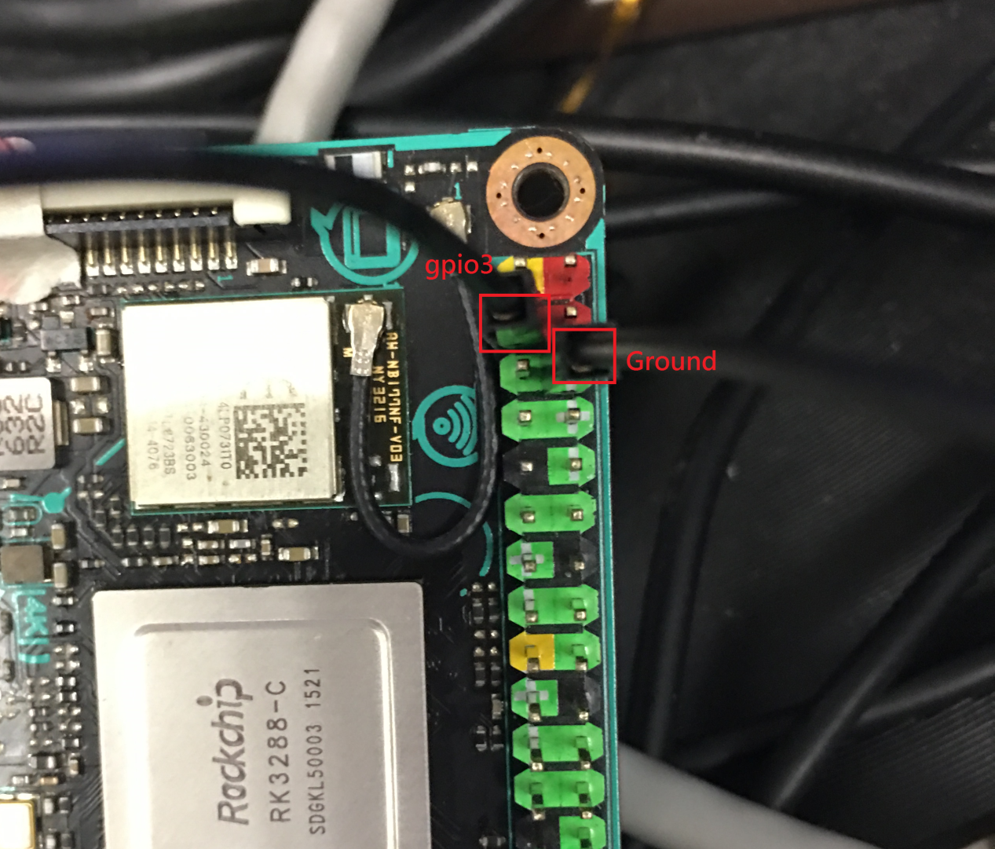

1. Look the gpio3 to pull down

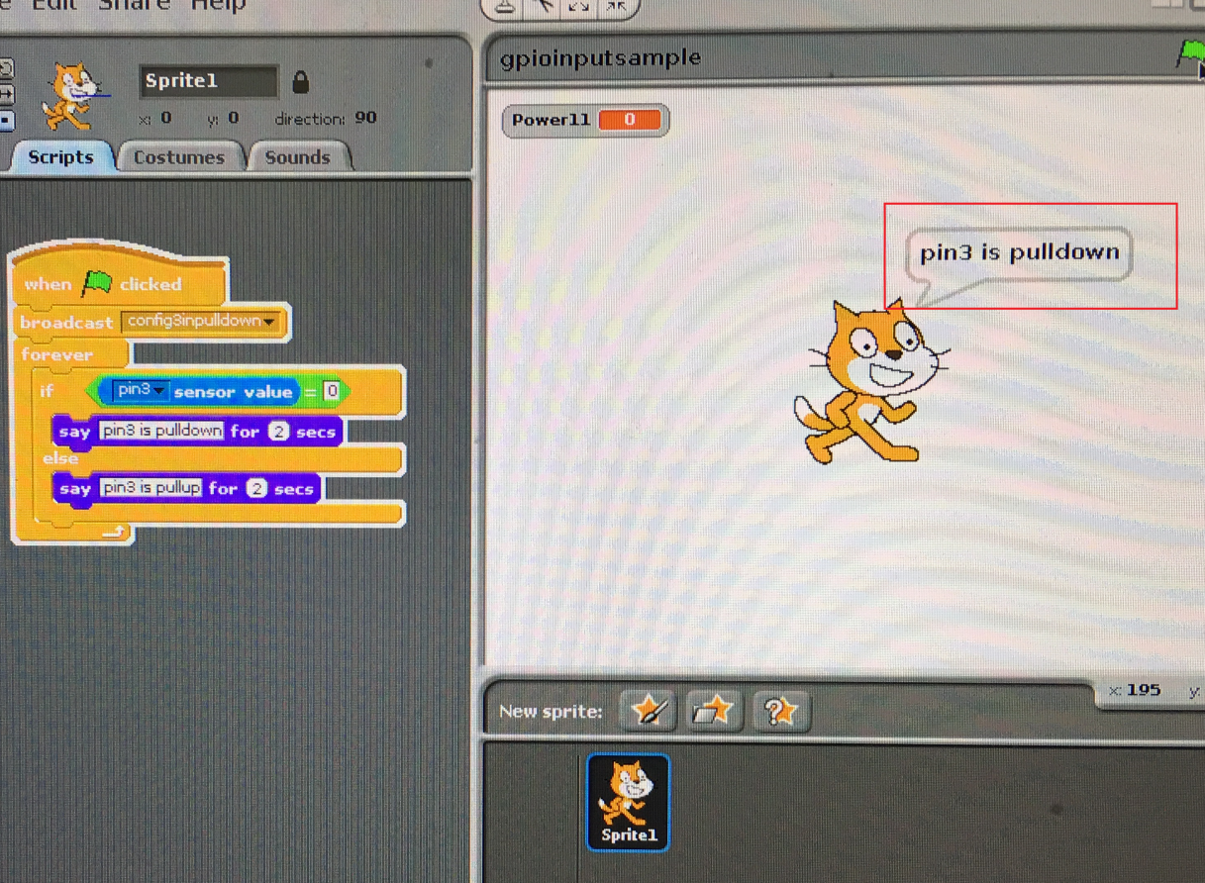

1. Sample 2 – PWM functions
2. Double click the following icon

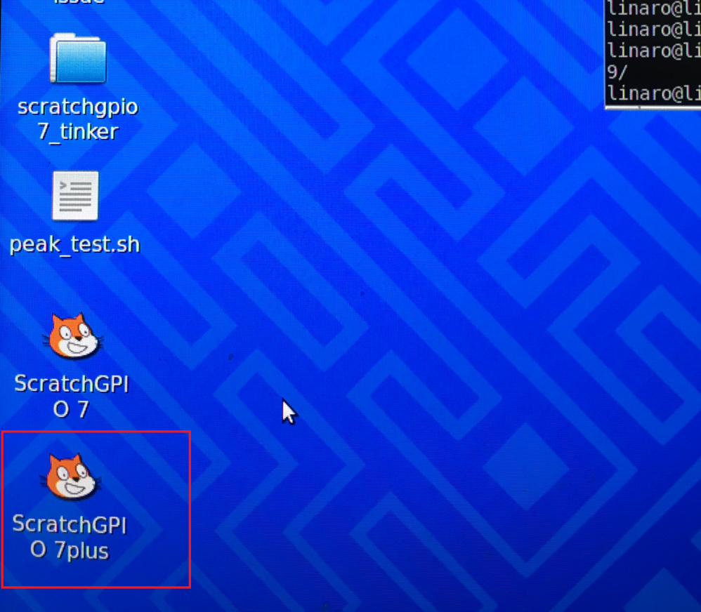

1. Execute the project

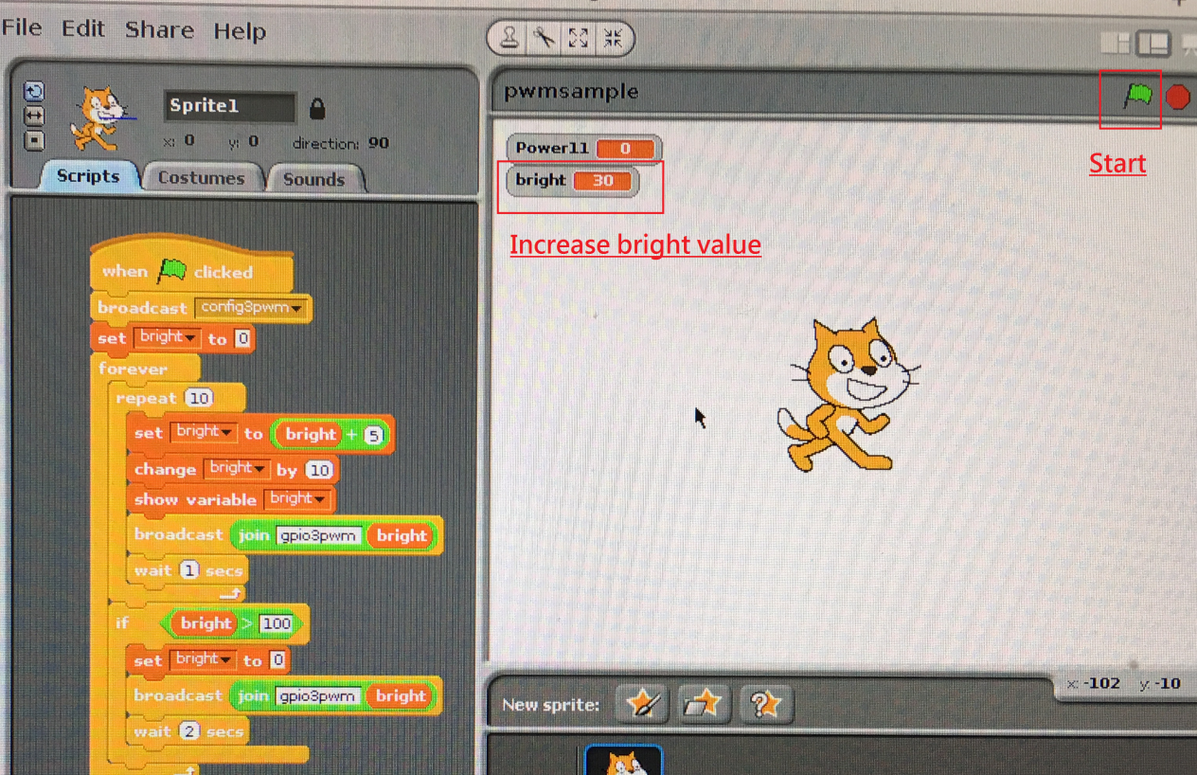

1. Look the gpio3 to bright by pwm function

